Go on assets with mouse then press left side of mouse then go on create then 2D then words on right will show up then go on sprites then more words on right will show up go on square.
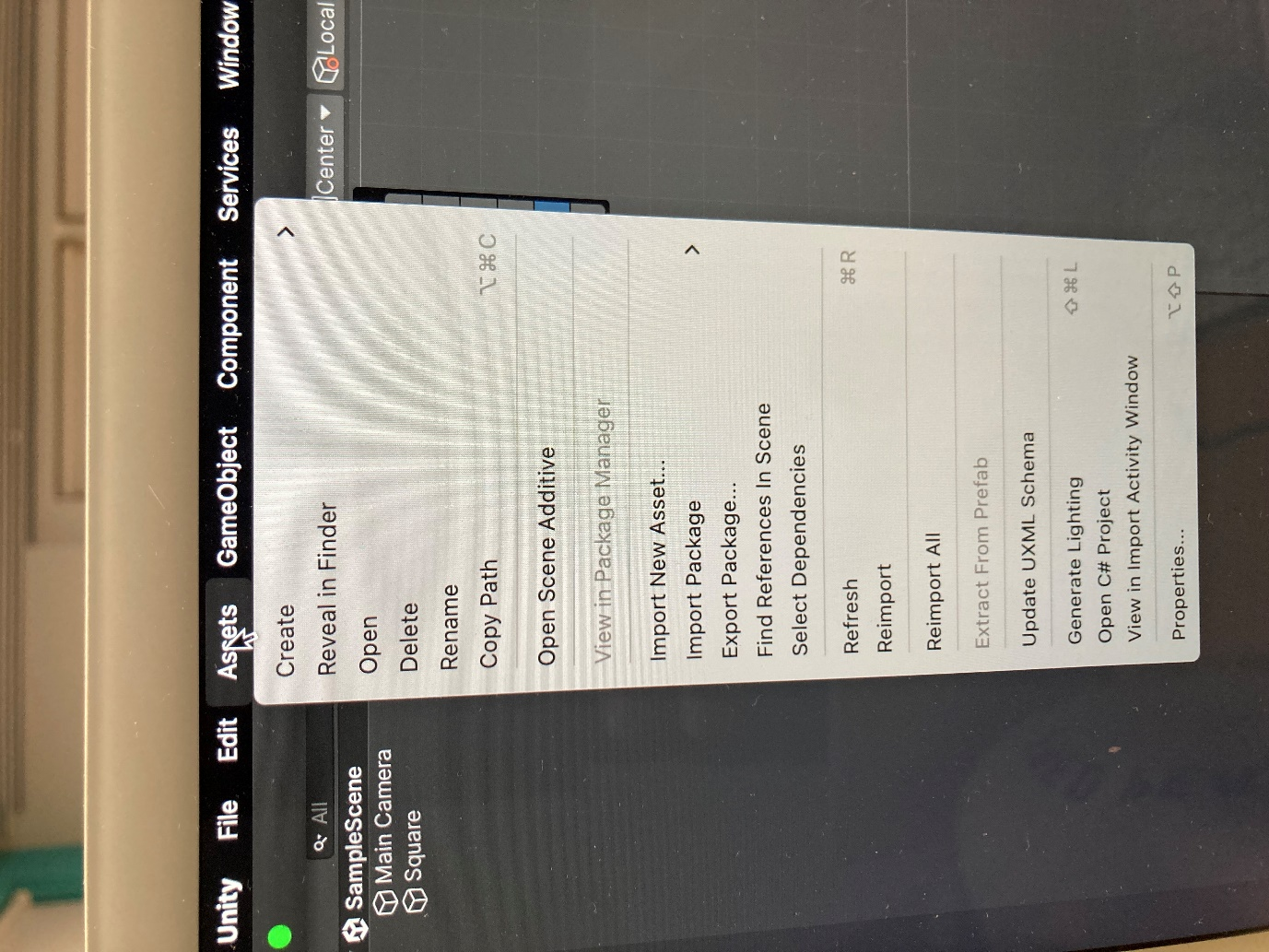
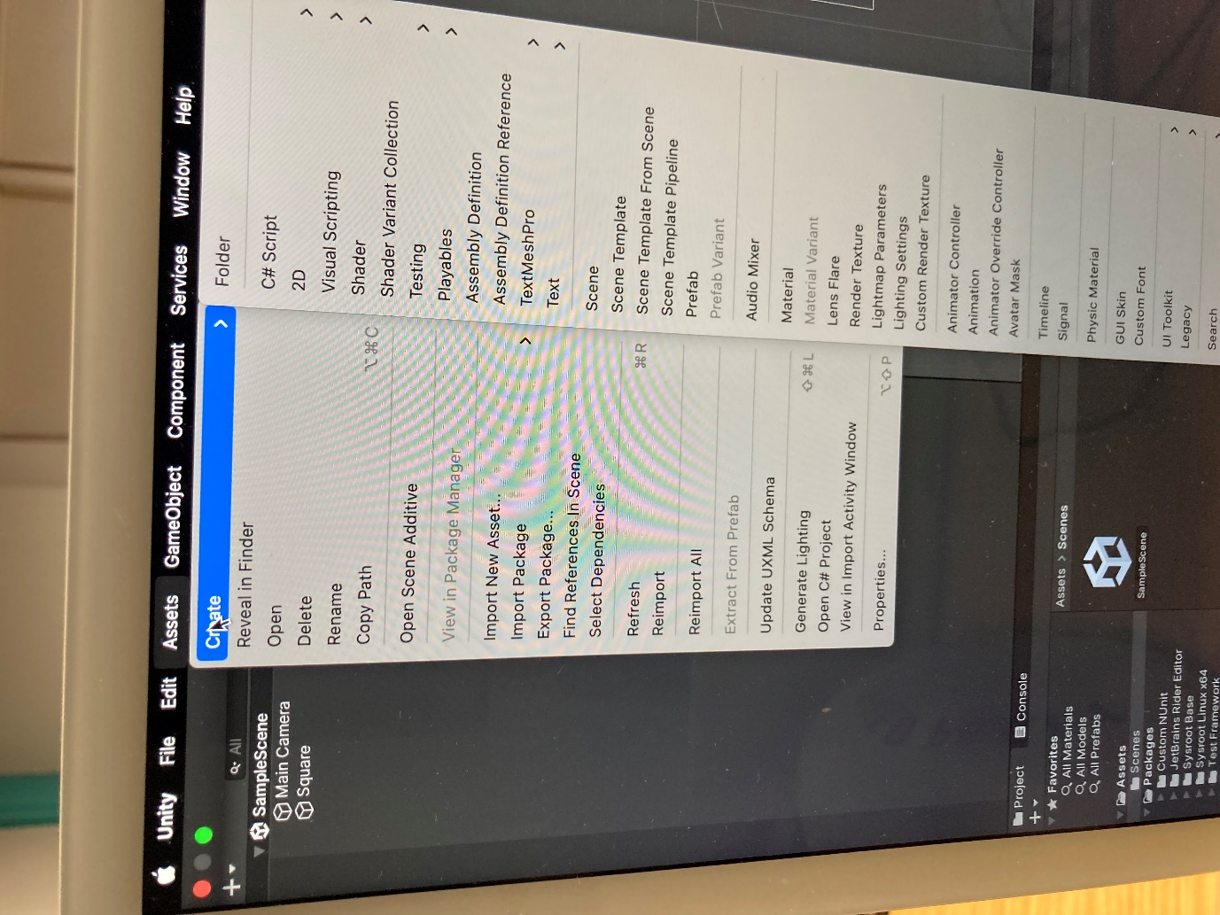
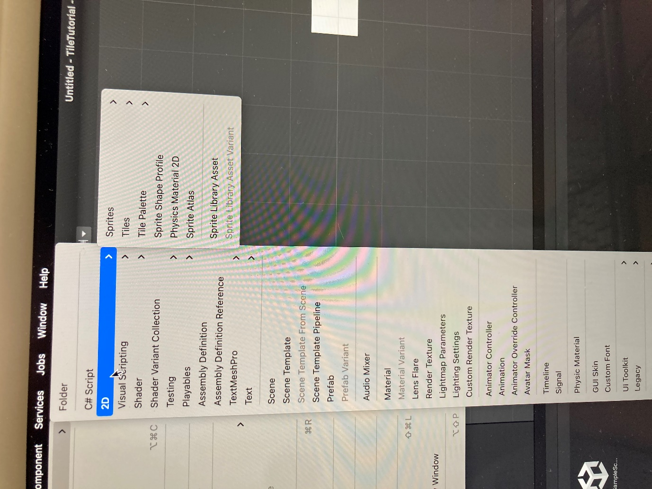
If you don’t see sprites then you have to go on window then package manager then press 2D 7 packages and can then see sprites.
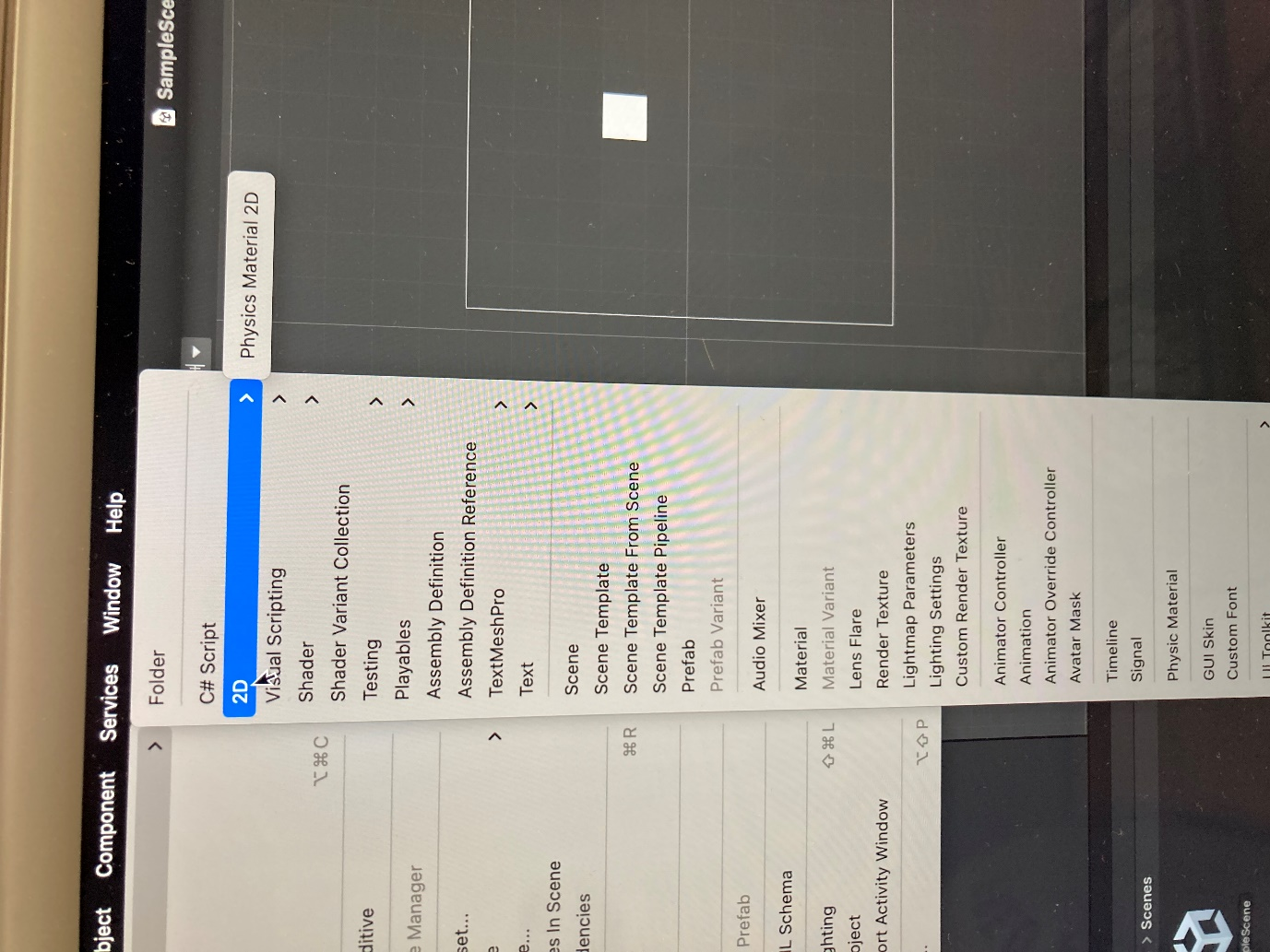
The reason why we do this is because we want something that we move up and down and to draw tile we wanted.
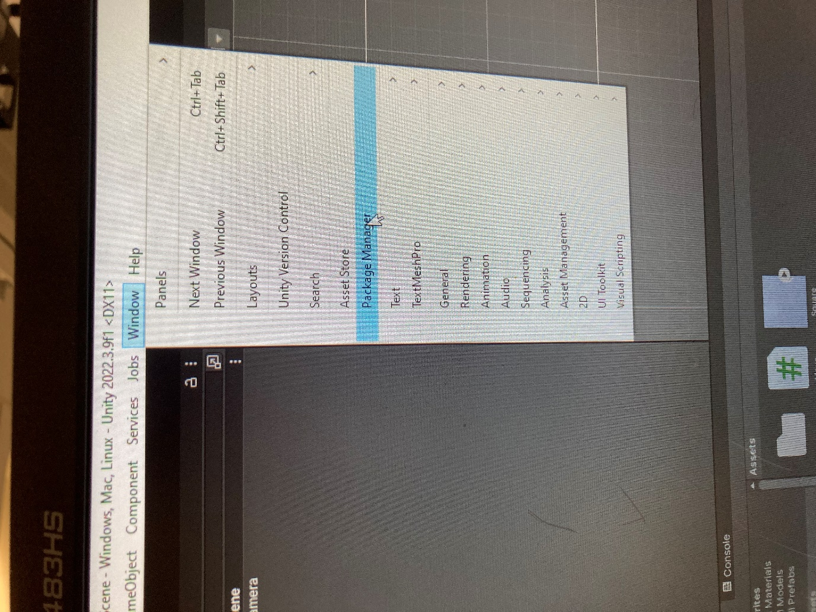
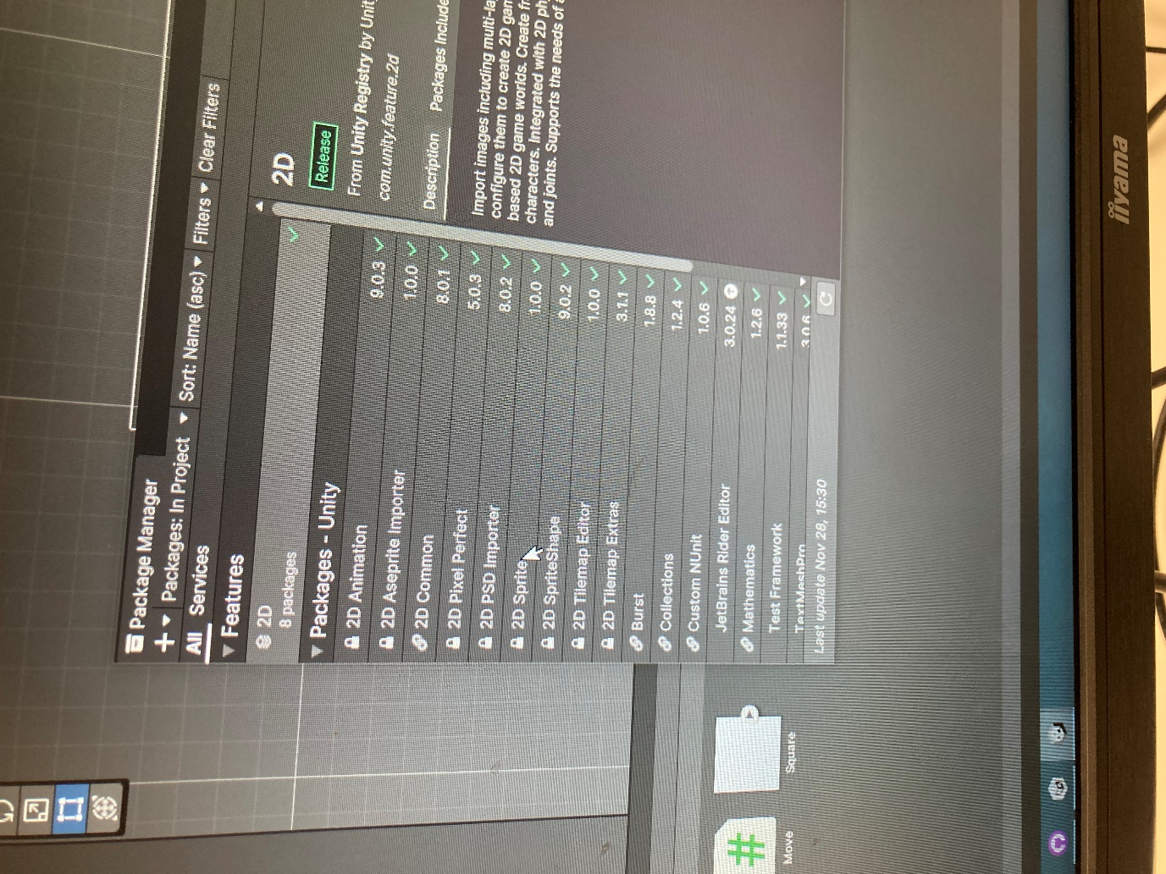
Drag square to sample scene. Change name to move and the reason why we change the name to move is because we don’t want the same name for everything because it will get confusing.
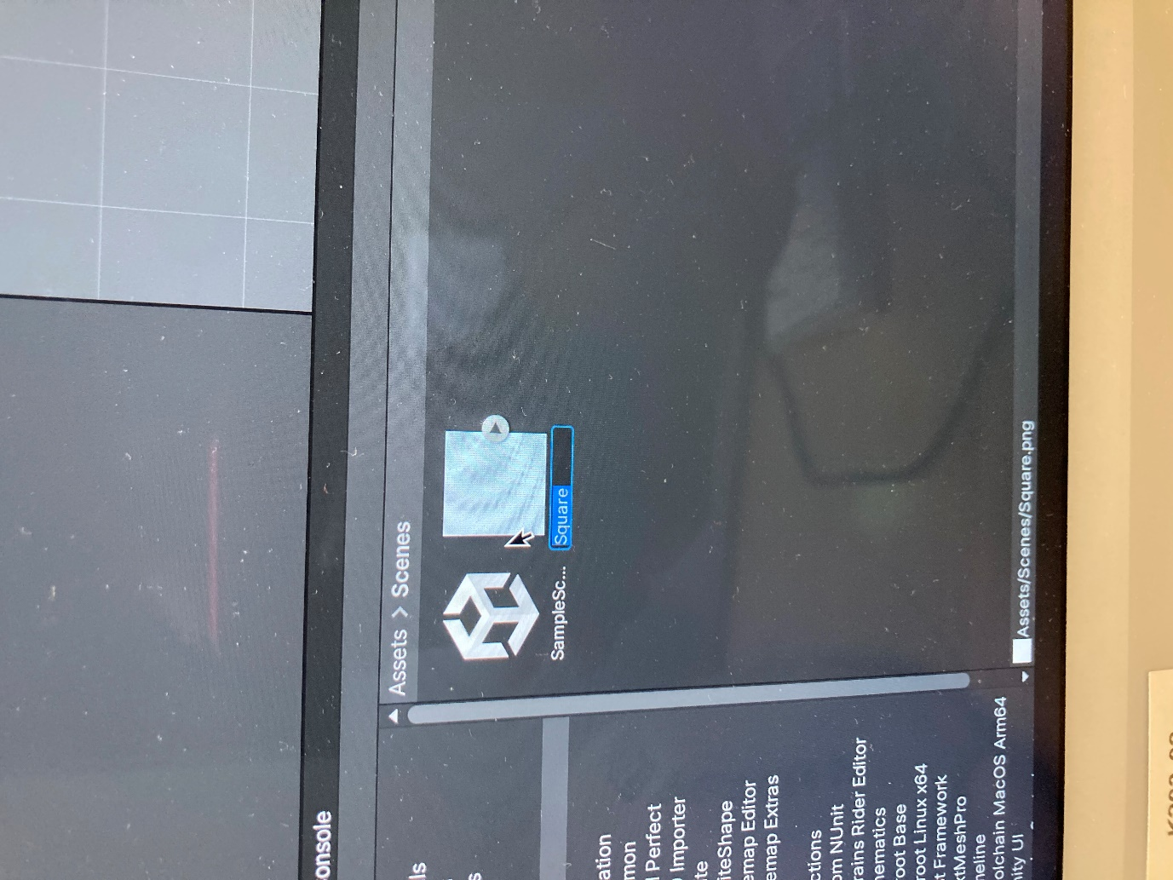
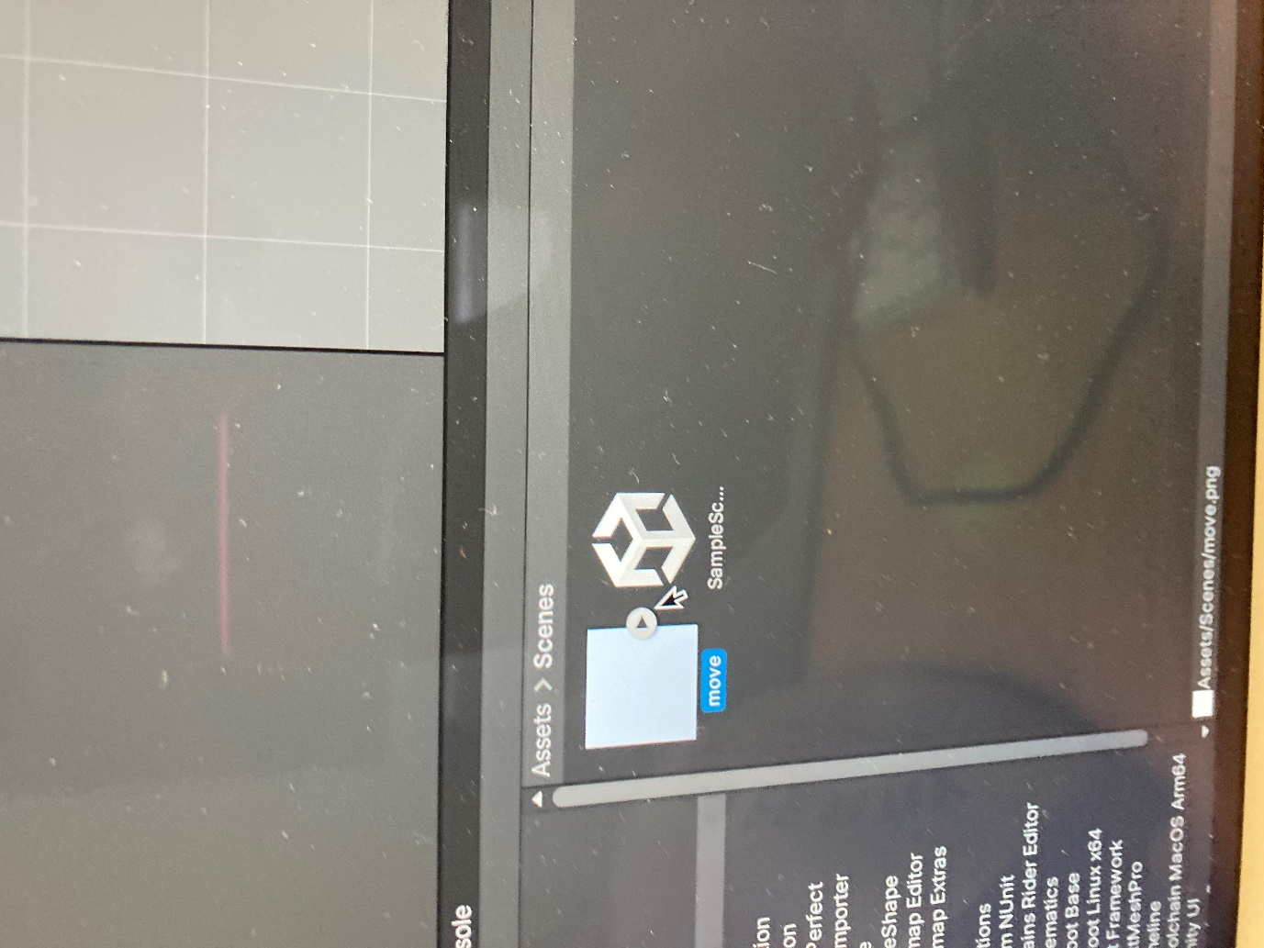

Drag mouse to square in sample scene. Make script by going to Create then go on C#Script on left and press left mouse on it and the reason go on c#script is because we want to make the square move up down left right.
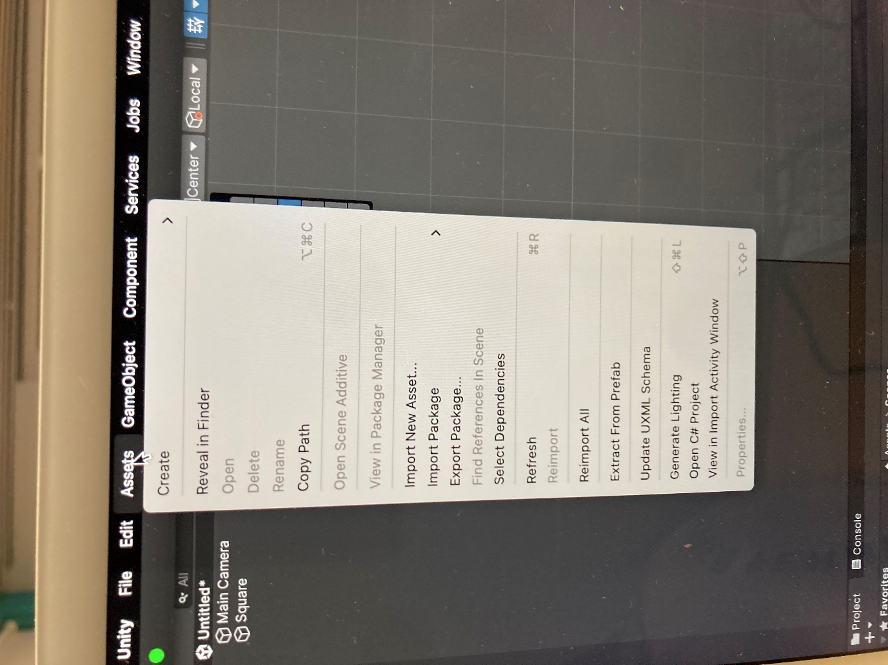
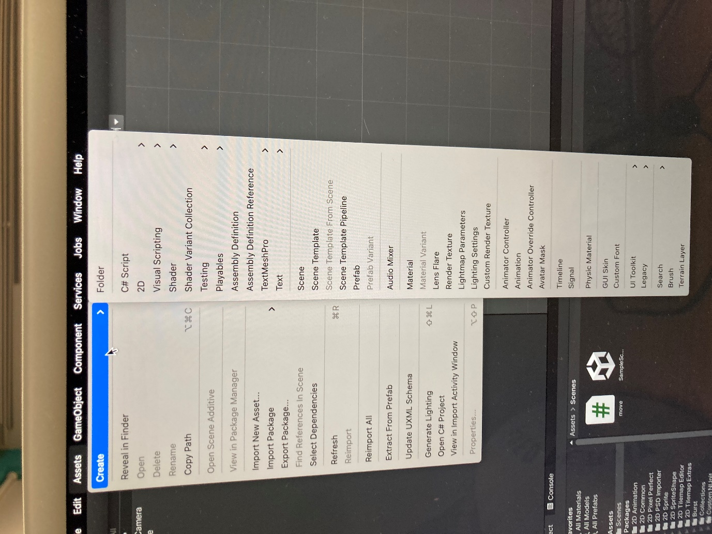
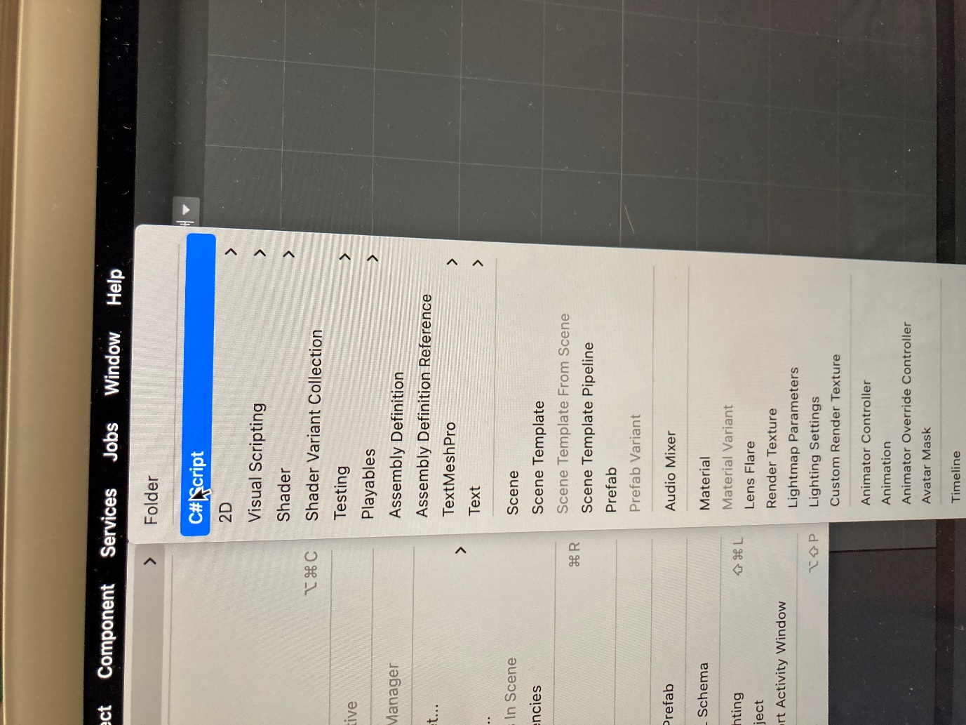

To make square move left right up and down press thing on right and it will show studios.
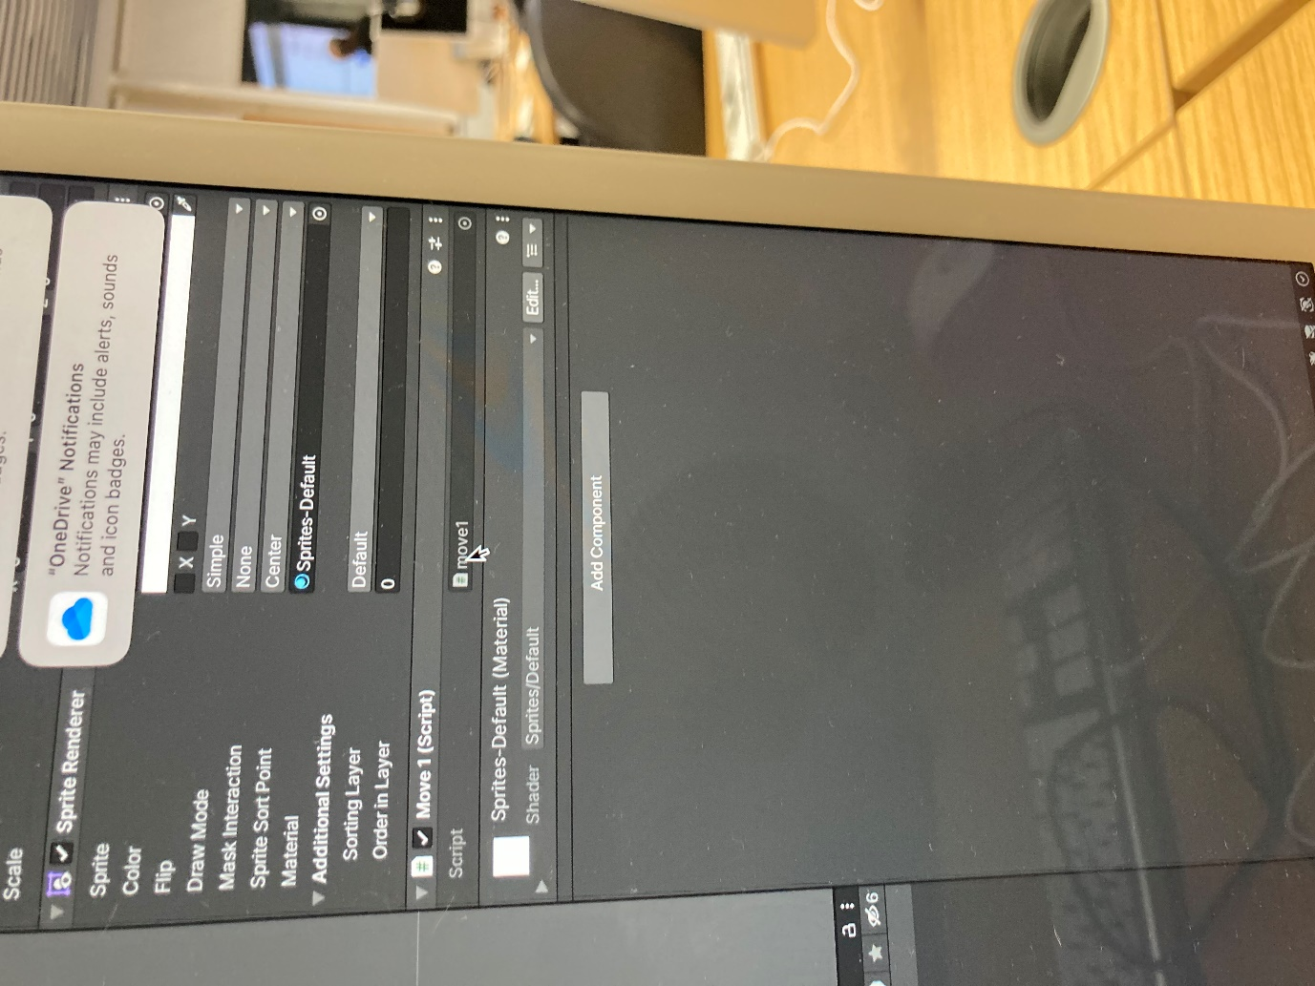
Put if(Input.GetKeyDown(KeyCode.LeftArrow)) then go under by pressing enter then put open curly brackets then go under by pressing enter again. Put curly open brackets then press enter. Put transform.Translate(Vector3.left);. Press enter and put closed curly brackets. Press enter again and put if(input.GetKeyDown(KeyCode.RightArrow)) then press enter and put open curly bracket then press enter again and put transform.Translate(Vector3.right); then press enter and put closed curly brackets. Press enter and put if(Input.GetKeyDown(KeyCode.UpArrow)) then press enter and put open curly brackets. Press enter and put transform.Translate(Vector3.up); then press enter and put closed brackets. Put it(Input.GetKeyDown(KeyCode.DownArrow)) then press enter and put open curly brackets. Press enter and put transform.Translate(Vector3.down)). Press enter and put closed curly brackets and press enter again and put curly brackets.


